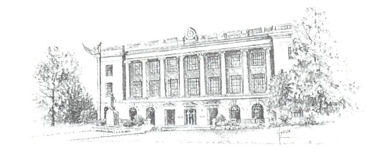
County of Pettis
415 South Ohio avenue, Suite 212, Sedalia, Missouri 65301
www.pettiscomo.com
Israel Baeza
Eastern Commissioner
660-826-5000 ext. 406
Bill Taylor
Presiding Commissioner
660-826-5000 ext. 405

Jim Marcum
Western Commissioner
660-826-5000 ext. 407

Cooperative Right-of-Way Maintenance Agreement

In an effort to better maintain public right-of-ways, allow for optimum road surfaces, and provide the motoring public the safest possible road system, the Pettis County Commission agrees to enter the following cooperative agreement:
With prior approval from the Pettis County Commission, the County may pay one-half of the costs or up to $500.00 per quarter mile, for brush removal and bulldozer work along County maintained roads, up to thirty (30) feet from the edge of the roadway as long as the area is within the county right-of-way. Landowner agrees that fence replacement will be at their expense and construction will comply with Pettis County Road and Bridge Standards. Landowner and their successors also agree to continue indefinitely brush control in the fence line to limit future growth.
It is further understood that the County will back slope and ditch the road prior to fence replacement or construction. Please contact the County Road and Bridge Department before construction begins on fence replacement.
It is also agreed that the utility locate shall be the responsibility of the contractor and the landowner, and the County shall not be liable for any damage caused by the contractor or the landowner.
The County Commission shall issue a W-9 to the landowner for the amount paid.
The proposed work as described below must be completed within one year after the approval of the County Commission. A paid invoice or receipt must be submitted before the County will issue a check for reimbursement. The maximum County reimbursement will be $__________________.
Land Owners Printed Name: ______________________________________________________________________
Description/Location of Proposed Work: ____________________________________________________________ _____________________________________________________________________________________________
Signature: |  |  | Contractor:
Address: |  |  | Address:
Date: |  |  | Signature:
Phone Number: |  |  | Phone Number:

Agreed to on this _________ day of __________________ in the year ________________.
______________________
Israel Baeza
Eastern Commissioner
______________________
Bill Taylor
Presiding Commissioner
______________________
Jim Marcum
Western Commissioner

